**CHAPTER 1**

**GLOBAL SERVICE DESK (GSD)**

**1.1 INTRODUCTION**

A **service desk** is a communications center that provides a single point of contact (SPOC) between a company and its customers, employees, and business partners. Sometimes there are situations where the employee or a customer faces some work related issues. These issues may vary from software installations to the salary and payment isues. The purpose of a service desk is to ensure that users receive appropriate help as soon as possible so that they can continue with their work which was acting as a hindrance in the completion of their work. It involves strategic planning, project management, change management and continuous improvement for the employees and the organization.

The **Global Service Desk** (GSD) Methodology designed here is a globally accessible desk for any organization and the associates related to the organization. The person seeking help can raise a ticket corresponding to the problem he is facing which will be resolved by the concerned authority. There is a specific team which controls all the requests in a GSD panel. The users can apply GSD using their identity portal. A ticket can be closed only after the user is satisfied with the response/action on the ticket. An option can be provided to upload a supporting document/image along with a request. There is an option to provide feedback for the whole process of ticket resolution.

This service desk does not only serves people logging incidents but is also a one stop solution that integrates people, products, processes for speedy incident solutions and improved end-user productivity by providing optimal service quality. This means each and every person is being fully aware of incidents when they happen and when they are resolved; leading to a transparent business methodology. This desk not only reduces the cost but also improves the productivity, end-user experience, and control and management reports.

The Global Service Desk is a complete packaged solution designed crucially to ensure the business is in control and provides 100% results for it by reducing the system failures and thus increasing the profits for the organization.

**1.2 AGILE METHODOLOGY**

**Agile software development** is an approach of software development in which requirements and solutions are a result of cumulative effort of self-organizing and cross-functional teams and their end-users. [1] The agile [2] methodology is basically a practice or a method in which the whole project is divided into small continuous iterations. Each iteration comprises of simultaneous development and testing of the project. It is unlike the waterfall methodology [3] where whole project is done all at once and the testing part is done at last. The Manifesto for Agile Software Development is built upon twelve basic principles: [4]

1. Providing customer satisfaction by timely delivery of end product.
2. Always welcome changes, even in the end stages of project.
3. Frequent delivery of working software (weekly).
4. Daily standup meet between developer and business associates.
5. Projects are built around motivated and trusted individuals.
6. Face-to-face conversation.
7. The primary measure of progress is the working software.
8. Constant pace is to be maintained.
9. Technical excellence and good design is paid continuous attention.
10. It is essential to maintain simplicity.
11. Self-organizing teams leads to best designs and architectures.
12. On a regular basis, team checks how to become more effective and makes the adjustments accordingly.

Although there are many differences between agile and waterfall model but one of them is the approach which they both use for quality and testing purposes. Waterfall methodology uses separate testing and build phase where build phase is followed by the testing phase. Agile methodology is famous for its simultaneous development and testing because here in each iteration testing is done. So if even a small error is found it is corrected simultaneously. Thus it reduces the time and increases the efficiency at the same time.

**AGILE PROJECT MANAGEMENT ROLES:**

There is a team of many people which lend their hand for the successful completion of a project. Under agile methodology, the team comprises of following bunch of people in each team which play a prominent role in the team: [5]

1. **Product owner:** The person who is the link between customer, business stakeholders and the development team. The product owner is the main person who knows about the product and the customer’s needs and priorities. He daily checks and clarifies the developer team about the requirements from the customer’s end.
2. **Development team members:** Product is created by these people. It includes a software developer, designer, writer, data engineer, tester, etc. whosoever is required for that particular project and has expertise in the field of project.
3. **Scrum master:** He is the main support system of the developing team who ensures that the agile process remains consistent. He is responsible for clearing the roadblocks from the organization’s side.
4. **Stakeholders:** These people provide valuable feedbacks that are importantbut are notultimately responsible for the product and also get affected by the project’s outcome.
5. **Agile mentor:** An experienced person who is good at implementing agile methodology into project and share his experience with the project team. He is a guide who gives his valuable knowledge and shares his experience about the project he has worked in past and advices the team for different approaches and techniques.

**AGILE PROJECT MANAGEMENT EVENTS**

Although there are many stages in the project development but when we follow agile methodology mainly seven events are included in project development. These can be explained as follows: [5]

1. **Project planning:** It is the initial planning of the project where roadmap of the project, product vision is done.[5]
2. **Release of planning:** Planning for the next bunch of product features to be released and only one release date is planned at a time.[5]
3. **Sprint:** Also known as the iterations, is a time duration in which team creates a functional product. This time duration generally lasts from one to four weeks, but cannot be larger than four weeks. All the sprints must be of the same duration.[5]
4. **Sprint planning:** Before the start of eachscrum **a** meeting is done so that all the work to be done in that scrum can be planned and the team can commit to its goals.[5]
5. **Daily scrum:** Each day in the morning a 15 minutes meetup is held by the development team members so as to know each other’s work to be done in that particular day, the work that is lagging and the work to be done in the future. Daily scrum enables the team to know whether they are having any hindrances in their path or not and how to improve their efficiency in any particular area.[5]
6. **Sprint review:** After each sprint is completed a meeting is held by the product owner where the development team shows how much part of the planned work is done and how much is left so that it must be included in the next sprint i.e. by updating the product backlog.[5]
7. **Sprint retrospective:** At the end of each sprint the scrum team will evaluate their methods and procedures and look forward to the changes they can implement for clearing the roadblocks so that the functionality of the project can be implemented.[5]

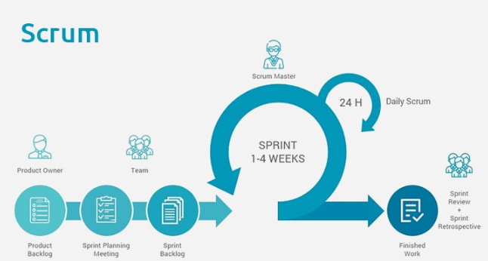[*]

**SOFTWARE REQUIREMENT SPECIFICATION**

**Technologies Recommended:**

|  |  |
| --- | --- |
| Front End | HTML5, CSS3, JavaScript |
| Middleware | Java (Servlet, JSP,WEB API2,MVC ) |
| Backend | Oracle |

Table 1:Technologies to be used

**Hardware and Software Requirements:**

|  |  |  |
| --- | --- | --- |
| Technology | Hardware | Software |
| Java | Desktop PC with 8GB RAM | 1. Eclipse IDE for Java EE Developers (Oxygen)  2. Tomcat 9  3. MySQL Community Server 8.0  4. Oracle 11g express version |

Table 2: Hardware and Software that are required

**Requirement Analysis:**

|  |  |  |  |
| --- | --- | --- | --- |
| **S.No.** | **Business**  **Requirement** | **Short Description** | **Description in detail** |
| 1 | Req_1 | User login | Ability of the system to create session for admin |
| 2 | Req_2 | User Registration | Ability of the system to procure the fundamental details of the user |
| 3 | Req_3 | User Authentication | Ability of the system to authenticate the user credentials of the registered user |
| 4 | Req_4 | User GSD Search | Ability of the system to search GSD type for user |
| **S.No.** | **Business**  **Requirement** | **Short Description** | **Description in detail** |
| 5 | Req_5 | User GSD raise | Ability of the system to raise GSD |
| 6 | Req_6 | User notification | Ability of the system to get notification regarding his GSD request |
| |  | | --- | | 7 | | Req_7 | User track request | Ability of the system to track all user GSD till current date |
| 8 | Req_8 | User close GSD | Ability of the system to close GSD request. |
| 9 | Req_9 | User logout | Ability of the system to close the session for user |
| 10 | Req_10 | Admin login | Ability of the system to create session for admin |
| 11 | Req_11 | Admin registration | Ability of the system to procure the fundamental details of the admin |
| 12 | Req_12 | Admin all GSD list | Ability of the system to get all user GSD request |
| 13 | Req_13 | Admin close request | Ability of the system to close the GSD request of each user. |
| 14 | Req_14 | Admin logout | Ability of the system to close the session for  admin |

Table 3: Business Requirement

**Functional Requirements**

The functional requirements are charted for each of the high level requirements called out in the earlier section:

Additionally, the following elements are captured for each business requirement in the table provided below:-

* Req. Type = (F Core Functionality, E Exception, UI User Interface, R Reporting)

** Priority of Requirement = (1=Base Functionality, 2=Advanced Functionality,

3=Additional Opportunities)

** Originator = (Name of the business process of the system/ department or function name in the customer organization)

The Requirements in this document are prioritized as follows:

|  |  |  |
| --- | --- | --- |
| **Value** | **Rating** | **Description** |
| 1 | Critical | The requirement is critical to the success of the project. The project will not be considered complete without this requirement. |
| 2 | High | This requirement is high in priority, but the project can be implemented at a bare minimum without this requirement. |
| 3 | Medium | This requirement is somewhat important, as it provides some value but the project can proceed without it. |
| 4 | Low | This is a low priority requirement, or a “nice to have” feature if time and cost allow it. |
| 5 | Future | If any future work is to be included |

Table 4: Description of the keywords used in Business Requirement

|  |  |  |  |  |  |  |
| --- | --- | --- | --- | --- | --- | --- |
| **Req. #** | **Rationale**  **Categorization** | **Business Requirement** | **Req.**  **Type**  **\*** | **Priority \*\*** | **Originator**  **\*\*\*** | **BR Traced to Business**  **Requirement / Use case ID** |
| Req_1.1 | User login | Login button for user login | UI | Critical | NA | Req_1 |
| Req_1.2 | User login | Clicking ‘Submit’ should validate the datatype constraints for each field | F | Critical | NA | Req_1 |
| Req_1.3 | User login | Creation of session for particular user | F | Critical | NA | Req_1 |
| Req_2.1 | User Registration | When the user clicks on the registration link, it should re-direct to registration form. | F | Critical | NA | Req_2 |
| Req_2.2 | User Registration | User needs to fill some of the basic attributes/fields as mentioned below in requirement: User First Name, User Last Name, Age, Gender,  Contact Number, User Id, Password | UI | Critical | NA | Req_2 |
| Req_2.3 | User Registration | Clicking ‘Submit’ should validate the datatype constraints for each field | F | Critical | NA | Req_2 |
| Req_2.4 | User Registration | User failing to provide information on the mandatory fields be provided with an alert message – ‘Please update the highlighted mandatory field(s).’ Also, highlight the missed out field in red | E | Medium | NA | Req_2 |
| Req_2.5 | User Registration | Post-successful field level validation, save the information in the database | F | Critical | NA | Req_2 |
| Req_2.6 | User Registration | Upon saving the information in the database, display the message ‘Your details are submitted successfully’. | E | Medium | NA | Req_2 |
| Req_3.1 | User Authentication | A registered user – is able click  ‘Login’ link, after keying in ‘User ID’ &  ‘Password’ field and get his credentials authenticated with the existing database entry. | F | Critical | NA | Req_3 |
| Req_.4. 1 | User GSD Search | User is able to access the user GSD page post the successful validation of the user credentials | F | Critical | NA | Req_4 |
| Req_4.2 | User GSD Search | Input type string for searching GSD by name | F | Critical | NA | Req_4 |
| Req_4.3 | User GSD Search | Clicking ‘Search’ to get list of GSDs from database | F | Critical | NA | Req_4 |
| Req_4.4 | User GSD Search | User failing to provide information on the mandatory fields be provided with an alert message – ‘Please update the highlighted mandatory field(s).’ Also, highlight the missed out field in red | E | Medium | NA | Req_4 |
| Req_4.5 | User GSD Search | Fields GSD search name, type are although text fields, checks needs to be enforced that the keyed in values are within in the valid values range. | F | Medium | NA | Req_4 |
| Req_5.1 | User GSD raise | Fields GSD raise must be mandatory, without raising it GSD ticket will not be created. | F | High | NA | Req_5 |
| Req_6.1 | User  notification | User must have raised request till current date | F | Critical | NA | Req_6 |
| Req_6.2 | User  notification | If no request found in database then empty list in notification | E | Medium | NA | Req_6 |
| Req_7.1 | User track request | Clicking on track request button for redirecting to track request page | F | High | NA | Req_7 |
| Req_7.2 | User track request | User is able to access the user track request page post the successful validation of the user ID | F | Critical | NA | Req_7 |
| Req_8.1 | User close  GSD | Clicking on close request button for close request option. | F | critical | NA | Req_8 |
| Req_8.2 | User close  GSD | Getting all GSD of user | F | Critical | NA | Req_8 |
| Req_8.3 | User close  GSD | Clicking ‘Close’ should check whether ticket is closed by Admin or not | F | Critical | NA | Req_8 |
| Req_9.1 | User logout | Clicking on the logout link, redirecting to login page. | F | Critical | NA | Req_9 |
| Req_9.2 | User logout | Closing session of user | F | Critical | NA | Req_9 |
| Req_10.  1 | Admin login | Login button for admin login | UI | Critical | NA | Req_10 |
| Req_10.  2 | Admin login | Clicking ‘Submit’ should validate the datatype constraints for each field | F | Critical | NA | Req_10 |
| Req_10.  3 | Admin login | Creation of session for particular admin | F | Critical | NA | Req_10 |
| Req_11.  1 | Admin  registration | When the admin clicks on the registration link, it should re-direct to registration form. | F | Critical | NA | Req_11 |
| Req_11.  2 | Admin  registration | Admin needs to fill some of the basic attributes/fields as mentioned below in requirement: Admin First Name, Admin Last Name, Age, Gender,  Contact Number, User Id, Password | F | Critical | NA | Req_11 |
| Req_11.  3 | Admin  registration | Clicking ‘Submit’ should validate the datatype constraints for each field | F | Critical | NA | Req_11 |
| Req_11.  4 | Admin  registration | Upon saving the information in the database, display the message ‘Your details are Registered successfully’. | E | Medium | NA | Req_11 |
| Req_12.  1 | Admin all GSD list | Clicking ‘All list’ button to redirect to All GSD page. | F | Critical | NA | Req_12 |
| Req_12.  2 | Admin all GSD list | Admin is able to access the user GSD list post the successful validation of the admin credentials | F | Critical | NA | Req_12 |
| Req_13.  1 | Adminclose request | Clicking button ‘close’ for that GSD | UI | Critical | NA | Req_13 |
| Req_13.  2 | Adminclose request | On clicking ‘close’ button updating user database. | F | Critical | NA | Req_13 |
| Req_14.  1 | Admin logout | ‘Logout’ button for logout functionality | UI | Critical | NA | Req_14 |
| Req_14.  2 | Admin logout | On clicking ‘logout’ button closing session for admin | F | Critical | NA | Req_14 |
| Req_14.  3 | Admin logout | Redirecting to admin login page | E | Medium | NA | Req_14 |

**Table:**

**Data tables:**

|  |  |  |  |  |
| --- | --- | --- | --- | --- |
| **Field**  **Name** | **Field Type** | **Data Type** | **Mandatory** | **Possible Values** |
| Admin First  Name | Text(50) | Alphabetic | Yes |  |
| Admin Last Name | Text(50) | Alphabetic | Yes |  |
| Age | Numeric(2) | Numeric | Yes |  |
| Gender | Drop Down | NA |  | Male, Female |
| Contact Number | Text(10) | Numeric | No |  |
| AdminId | Text(15) | Alphanumeric | Yes |  |
| Password | Text(15) | Alphanumeric | Yes |  |

**Table:**

|  |  |  |  |  |
| --- | --- | --- | --- | --- |
| **Field**  **Name** | **Field Type** | **Data Type** | **Mandatory** | **Possible Values** |
| User First  Name | Text(50) | Alphabetic | yes |  |
| User Last Name | Text(50) | Alphabetic | yes |  |
| Age | Drop Down | NA | yes | 18-120 |
| Gender | Drop Down | NA |  | Male, Female |
| Contact Number | Text(10) | Numeric | No |  |
| Address | Scrolling text box(100) | Alphanumeric | No |  |
| City | Text(50) | Alphabetic | yes |  |
| Zip Code | Text(10) | Numeric | yes |  |

|  |  |  |  |
| --- | --- | --- | --- |
| **Field**  **Name** | **Field Type** | **Data Type** | **Mandatory** |
| GSD Name | Text(50) | Alphabetic | Yes |
| GsdId | Numeric(20) | Numeric | Yes |

|  |  |  |  |  |
| --- | --- | --- | --- | --- |
| **Field Name** | **Field Type** | **Data Type** | **Mandatory** | **Possible Values** |
| Notification ID | Text(50) | Alphabetic | Yes |  |
| Notification Type | Text(50) | Alphabetic | Yes |  |
| Notification Text | Text(50) | Alphabetic | Yes | 18-120 |

**OBJECTIVE**

Below are the objectives that shall be fulfilled post the execution of this project:

1. User registration & credential authentication
2. Raising GSD ticket with supporting document
3. Admin can access all GSD’s raised by the employees and can close it after problem resolves.
4. User can view all his GSD’s request till current date
5. User can close his GSD ticket after issue has been resolved.

**SYSTEM DESIGN**

Below is the overall functional flow of the project including the components of interaction.

**User End:**

The user end side has the following functionality i.e. the pre-requisites are mentioned here. There is a requirement of login/signup page which should be linked up with the registration page to enable new users to register. Login page, on successful login, must create a session for the user and take him to the GSD portal page. This page must contain search gsd, notification, track requests links. These links are further connected to other links which have their own functionality.



**Admin End:**

The admin end side has the following functionality i.e. the pre-requisites are mentioned here. The front page must be login /Signup page which must be linked to registration page which gives way for new admins to register. Then it should redirect to All GSD page where the admin can see all the GSD tickets raised by all the users till date. He should have the authority to close or review the GSD ticket.



## Use case ‘User Registration’

### Use case attributes

**Scope:**

* User registration

**Actors:**

* User – the operator

**Trigger:**

Click ‘Submit’ button in the ‘User Registration’ page

**Pre-Condition:**

User being able to access the homepage & get redirected to the ‘User Registration’ page upon click of ‘Register if new’ link.

**Post Condition:**

User is in the enrollment page & submit details

**Flow of Events:**

User at homepage 🡪 Click ‘Register if new’ link 🡪 User is in the enrollment page 🡪 User details are submitted and added onto the database.

**Primary Scenario:**

A new user – is able to click ‘Register if new’ link and able to provide his details and get enrolled in the system.

### Business Rules

Business rules should be defined using the following attributes: -

1. When the user clicks on the registration link, it should re-direct to registration form.
2. User needs to fill some of the basic attributes/fields as mentioned below in requirement: First Name, Last Name, Age, Gender, Contact Number, User Id, and Password.
3. Clicking ‘Submit’ should validate the datatype constraints for each field. User failing to provide information on the mandatory fields be provided with an alert message – ‘Please update the highlighted mandatory field(s).’ Also, highlight the missed out field in red
4. User failing to provide information on the mandatory fields be provided with an alert message-‘Please update the highlighted mandatory field(s).’ Also, highlight the missed out field in red.
5. Post-successful field level validation, save the information in the database
6. Upon saving the information in the database, display the message ‘Your details are submitted successfully’.
7. A registered user – is able click ‘Login link’ after keying in ‘User ID’ & ‘Password’ field and get his credentials authenticated with the existing database entry.

### UI Requirements

Here is a prototype on how the homepage should look like.

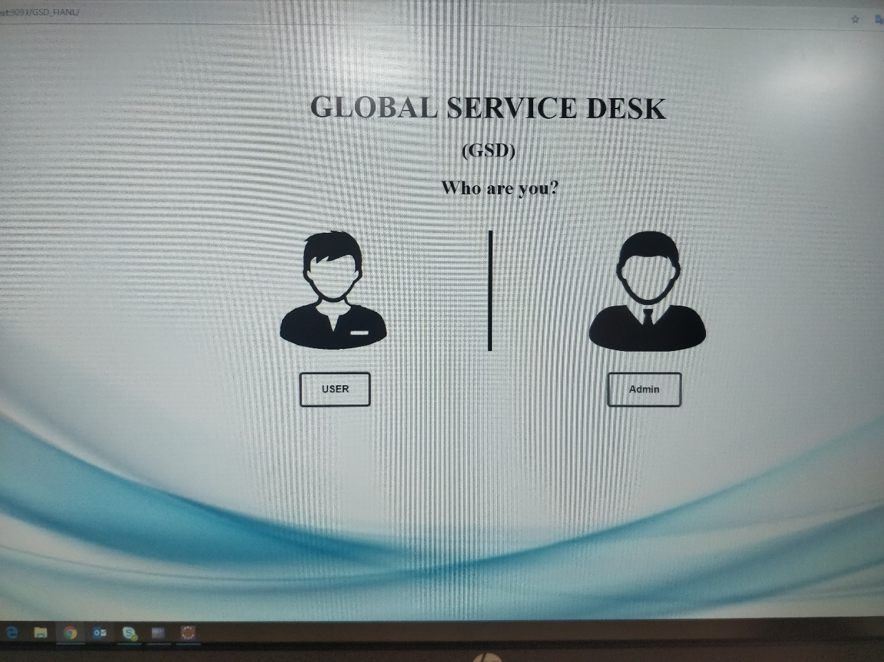

Here is a prototype on how the ‘User Registration’ page should look like.

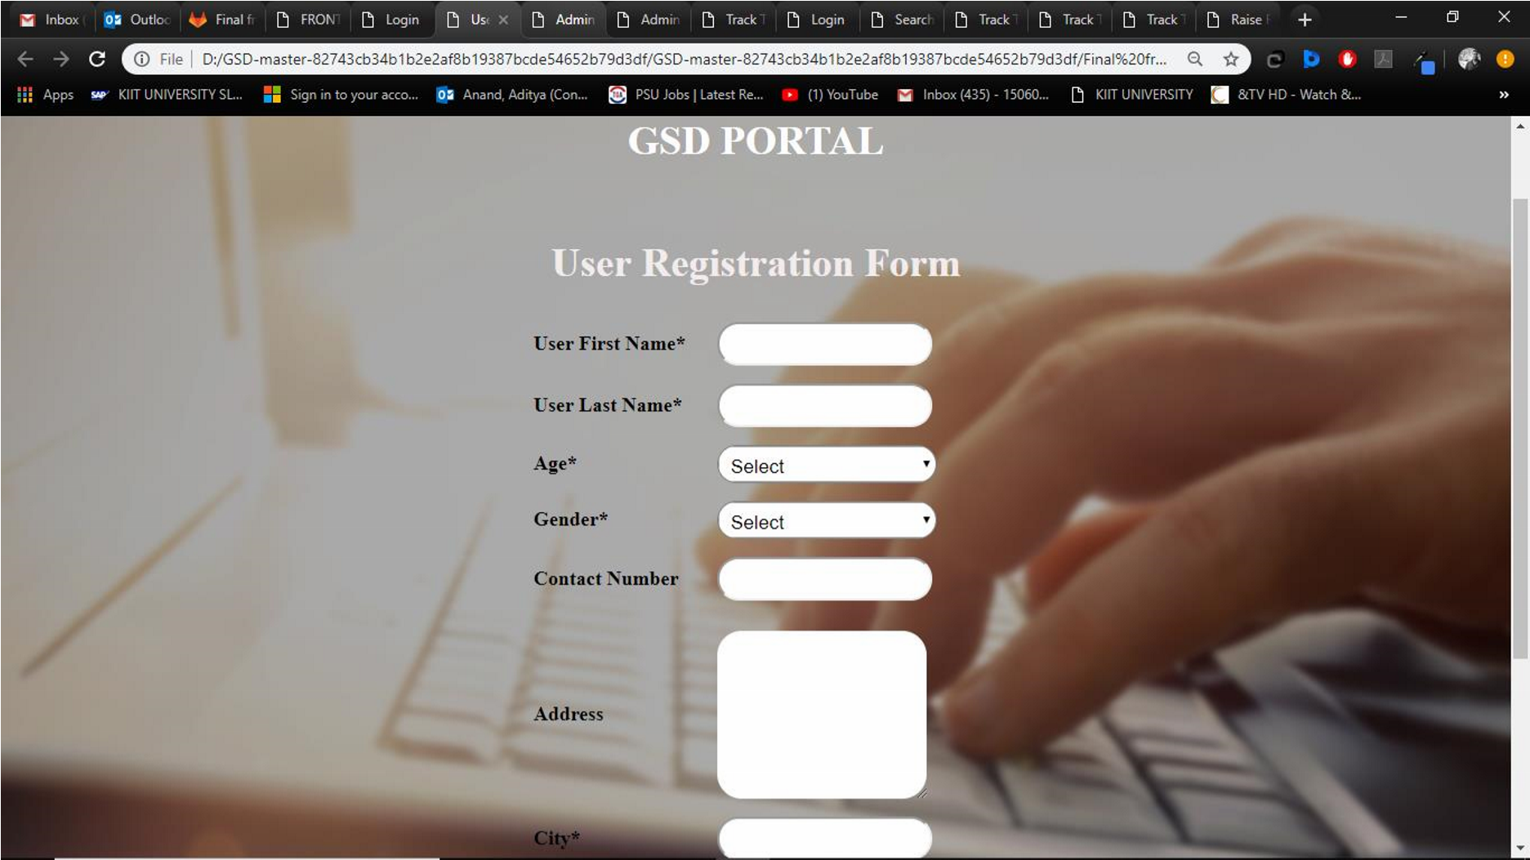

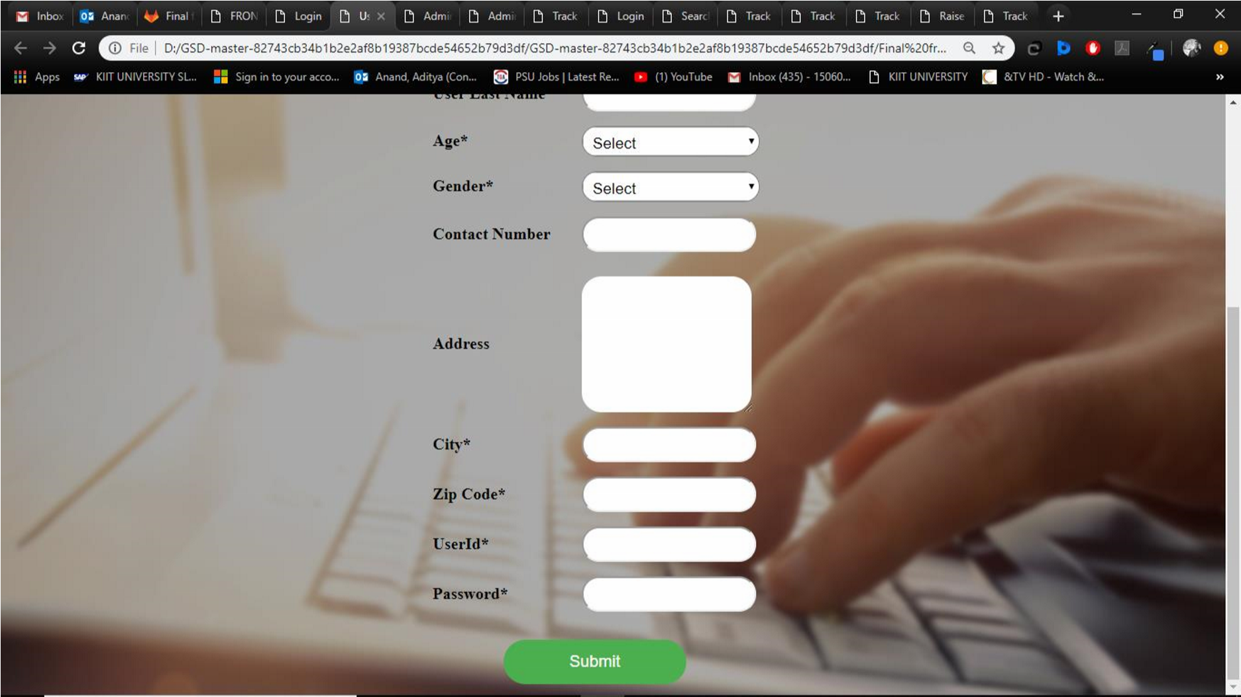

## Use case ‘User Login and Authentication’

### Use case attributes.

**Scope:**

* User Login and authentication

**Actors:**

User – the operator

**Trigger:**

Click ‘Login’ link, after keying in ‘UserID’ & ‘Password’ field.

**Pre-Condition:**

User being able to access the homepage

**Post Condition:**

User is in the Search GSD page.

**Flow of Events:**

User at homepage 🡪 Key in ‘UserID’ & ‘Password’ field 🡪 User credentials are validated 🡪 Search GSD (homepage of the user) page is displayed.

**Primary Scenario:**

A registered user – is able click ‘Login’ link, after keying in ‘UserID’ & ‘Password’ field and get his credentials authenticated with the existing database entry.

**Alternative Scenario:**

A registered user – is able click ‘Login’ link, after keying in ‘UserID’ & ‘Password’ field and unable to get his credentials authenticated. The user is presented with relevant error messages:

* Invalid User ID – ‘The userid provided does not exist in our records’
* Incorrect Password – ‘Password provided is incorrect. Please reach out to your system admin.’

### Business Rules

Business rules should be defined using the following attributes:-

* A registered user – is able click ‘Login’ link, after keying in ‘UserID’ & ‘Password’ field and get his credentials authenticated with the existing database entry.
* Login button for user login
* Clicking ‘Submit’ should validate the datatype constraints for each field
* Creation of session for particular user.

### UI Requirements

Here is a prototype on how the user login should look like.

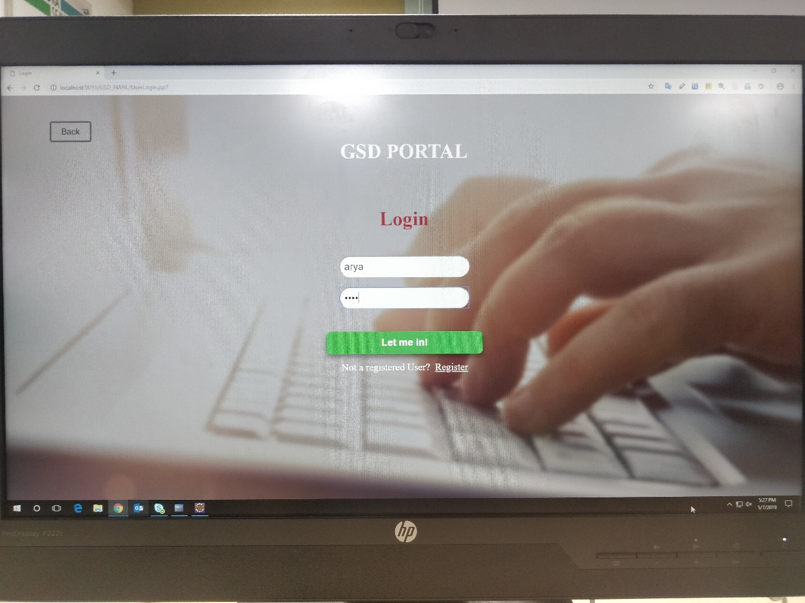

## Use case ‘Admin Registration’

**Scope:**

* Admin registration

**Actors:**

* Admin – the operator

**Trigger:**

Click ‘Submit’ button in the ‘Admin Registration’ page

**Pre-Condition:**

User being able to access the homepage & get redirected to the ‘User Registration’ page upon click of ‘Register if new’ link.

**Post Condition:**

User is in the enrollment page & submit details

**Flow of Events:**

User at homepage 🡪 Click ‘Register if new’ link 🡪 User is in the enrollment page 🡪 User details are submitted and added onto the database.

**Primary Scenario:**

A new user – is able to click ‘Register if new’ link and able to provide his details and get enrolled in the system.

### Business Rules

Business rules should be defined using the following attributes: -

* + - When the admin clicks on the registration link, it should re-direct to registration form.
    - Admin needs to fill some of the basic attributes/fields as mentioned below in requirement: First Name, Last Name, Age, Gender, Contact Number, Admin Id, Password
* Clicking ‘Submit’ should validate the datatype constraints for each field. Admin failing to provide information on the mandatory fields be provided with an alert message – ‘Please update the highlighted mandatory field(s).’ Also, highlight the missed out field in red
* User failing to provide information on the mandatory fields be provided with an alert message - ‘Please update the highlighted mandatory field(s).’ Also, highlight the missed out field in red.
* Post-successful field level validation, save the information in the database
* Upon saving the information in the database, display the message ‘Your details are submitted successfully’.
* A registered admin – is able click ‘Login link’ after keying in ‘AdminID’ & ‘Password’ field and get his credentials authenticated with the existing database entry.

### UI Requirements

Here is a prototype on how the ‘Admin Registration’ page should look like.

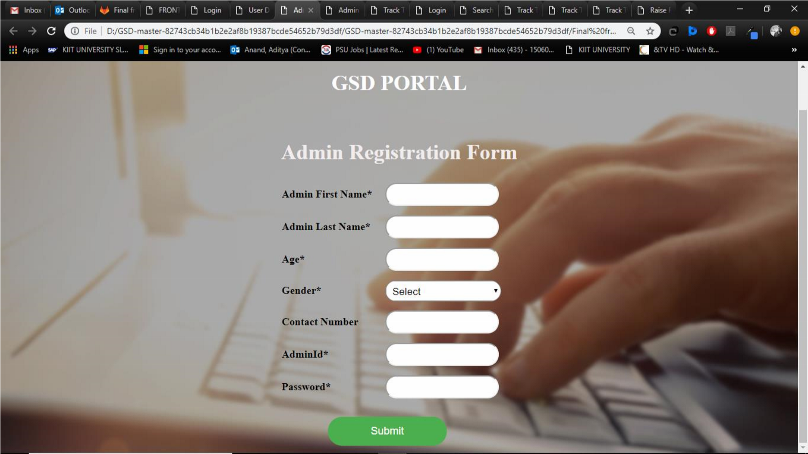

## Use case ‘Admin Login and Authentication’

### Use case attributes.

**Scope:**

* Admin Login and authentication

**Actors:**

Admin – the operator

**Trigger:**

Click ‘Login’ link, after keying in ‘AdminID’ & ‘Password’ field.

**Pre-Condition:**

Admin being able to access the homepage

**Post Condition:**

Admin is in the Search GSD page.

**Flow of Events:**

User at homepage 🡪 Key in ‘AdminID’ & ‘Password’ field 🡪 User credentials are validated 🡪 Admin all GSD list (homepage of the user) page is displayed.

**Primary Scenario:**

A registered admin – is able click ‘Login’ link, after keying in ‘AdminID’ & ‘Password’ field and get his credentials authenticated with the existing database entry.

**Alternative Scenario:**

A registered user – is able click ‘Login’ link, after keying in ‘AdminID’ & ‘Password’ field and unable to get his credentials authenticated. The admin is presented with relevant error messages:

* Invalid Admin ID – ‘The userid provided does not exist in our records’
* Incorrect Password – ‘Password provided is incorrect. Please reach out to your system admin.’

### Business Rules

Business rules should be defined using the following attributes:-

* A registered admin – is able click ‘Login’ link, after keying in ‘AdminID’ & ‘Password’ field and get his credentials authenticated with the existing database entry.
* Login button for admin login
* Clicking ‘Submit’ should validate the datatype constraints for each field
* Creation of session for particular user.

### UI Requirements

Here is a prototype on how the admin login should look like.

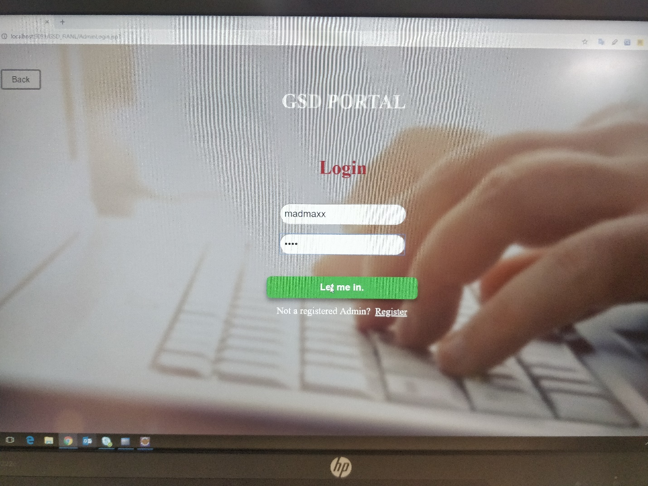

## Use case ‘User Search GSD’

### Use case attributes.

**Scope:**

* User Search GSD

**Actors:**

User – the operator

**Pre-Condition:**

User being able to access the homepage

**Post Condition:**

User is in the Search GSD page.

**Flow of Events:**

User at Search GSD page 🡪 Search Key in Search engine 🡪 submit 🡪 Track Request 🡪 Notifications 🡪 Close Ticket.

**Primary Scenario:**

A registered user – is able to get into the homepage i.e. GSD search page, where he enters the keyword of the issue to be raised. User can also track the request, get notifications, and close the ticket.

### Business Rules

Business rules should be defined using the following attributes:-

* User is able to access the user GSD page post the successful validation of the user credentials.
* Input type string for searching GSD by name
* Clicking ‘Search’ to get the list of all GSDs from database.
* User failing to provide information on the mandatory fields be provided with an alert message – ‘Please update the highlighted mandatory field(s).’ Also, highlight the missed out field in red.
* Fields GSD Search name, type are although text fields, checks needs to be enforced that the keyed in values are within in the valid values range.

### UI Requirements

Here is a prototype on how the Search GSD page should look like.

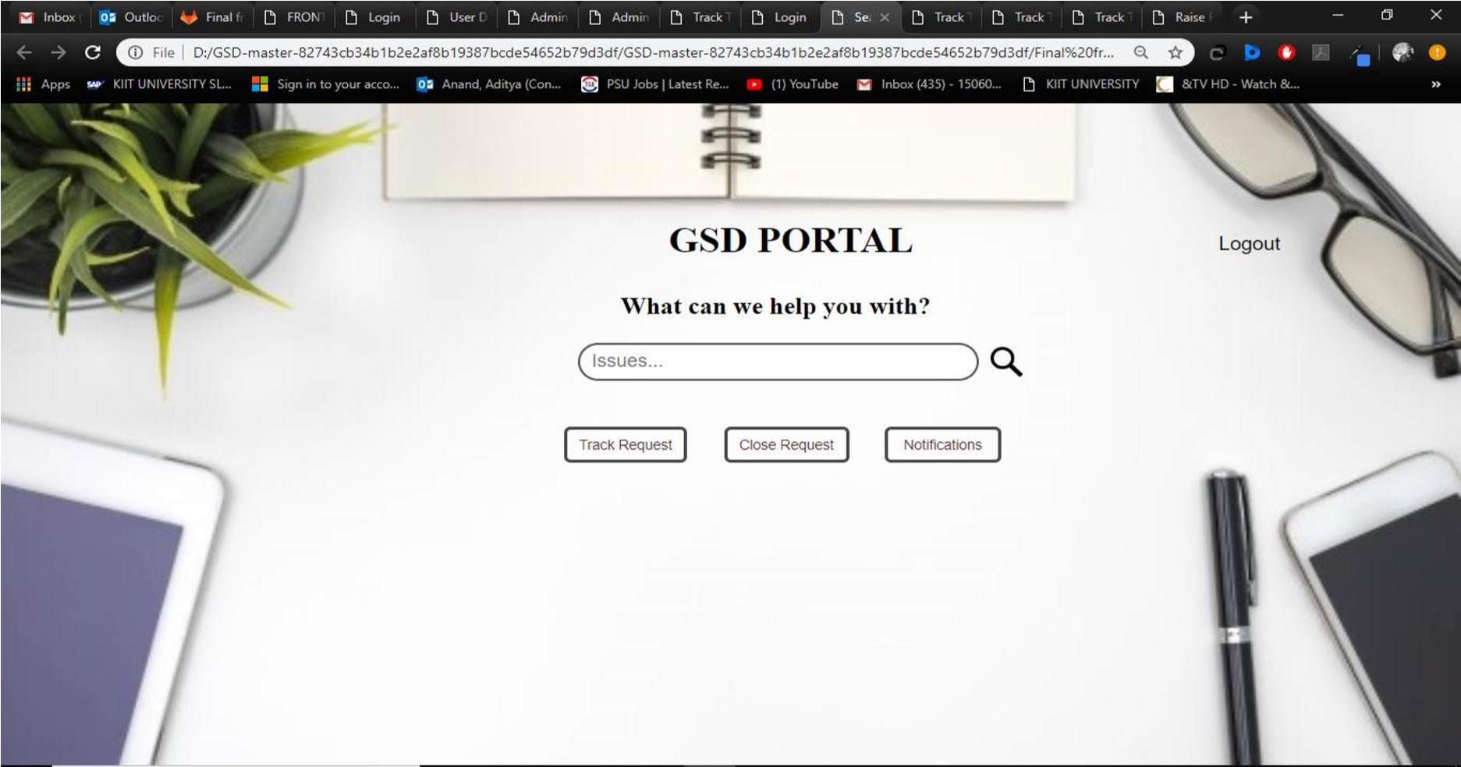

## Use case ‘User Raise ticket’

### Use case attributes.

**Scope:**

* User Search GSD

**Actors:**

User – the operator

**Pre-Condition:**

User being able to access the homepage and raise ticket option after clicking on Search.

**Post Condition:**

User is in the Raise GSD page.

**Flow of Events:**

User at Search GSD page 🡪 Raise ticket button 🡪 User at Raise Ticket page 🡪 Create a GSD request 🡪 click on the ticket to be raised 🡪submit.

**Primary Scenario:**

A registered user – is able to get into the Raise GSD page.

### Business Rules

Business rules should be defined using the following attributes:-

* Fields GSD raise must be mandatory, without raising it GSD ticket will not be created.
* User must have raised request till current date.

### UI Requirements

Here is a prototype on how the Raise Ticket page should look like.

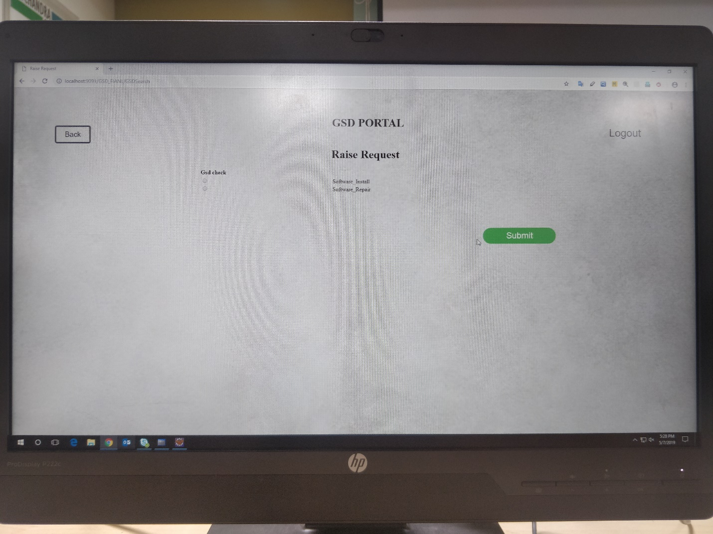

## User case ‘Track Request’

### Use case attributes.

**Scope:**

* Track Request page

**Actors:**

User – the operator

**Pre-Condition:**

User being able to track the status of the request raised by clicking on the Track ticket option in the Search GSD page.

**Post Condition:**

User is in the Track ticket page.

**Flow of Events:**

User at Search GSD page 🡪 Click on Track ticket 🡪 user at Track ticket page 🡪 User enters the ticket id and fetched data about its status.

**Primary Scenario:**

A registered user – is able to get into the Track Request page.

### Business Rules

Business rules should be defined using the following attributes:-

* User must have raised request till current date.
* If no request found in database then empty list in notifications.

### UI Requirements

Here is a prototype on how Track Request page should look like.

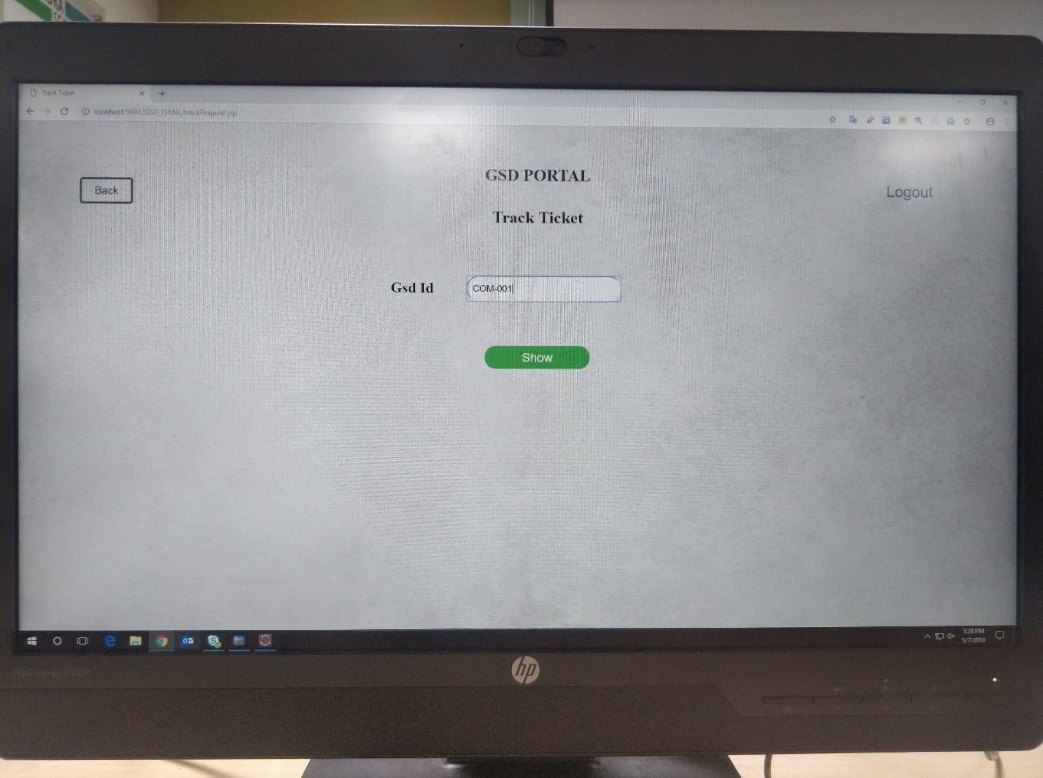

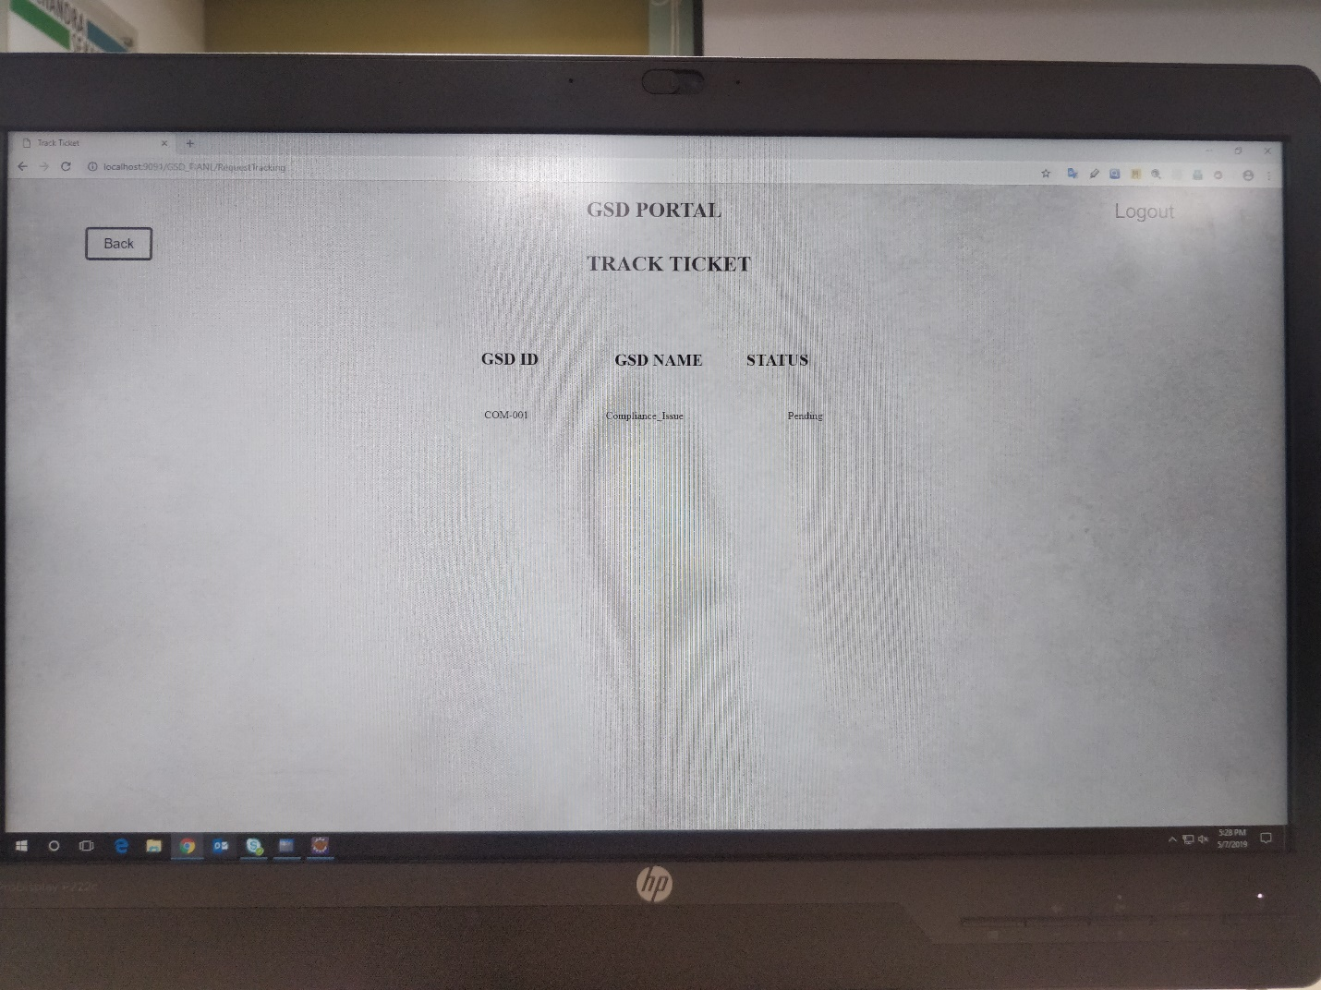

## Use case ‘Notifications’

### Use case attributes.

**Scope:**

* Notifications page

**Actors:**

User – the operator

**Pre-Condition:**

User being able to view all the notifications he received.

**Post Condition:**

User is in the Notifications page.

**Flow of Events:**

User at Notifications page 🡪 View notifications

**Primary Scenario:**

A registered user – is able to get into the Notifications page.

### Business Rules

Business rules should be defined using the following attributes:-

* User must have raised request till current date.
* If no request found in database then empty list in notifications.

### UI Requirements

Here is a prototype on how the notifications page hould look like.

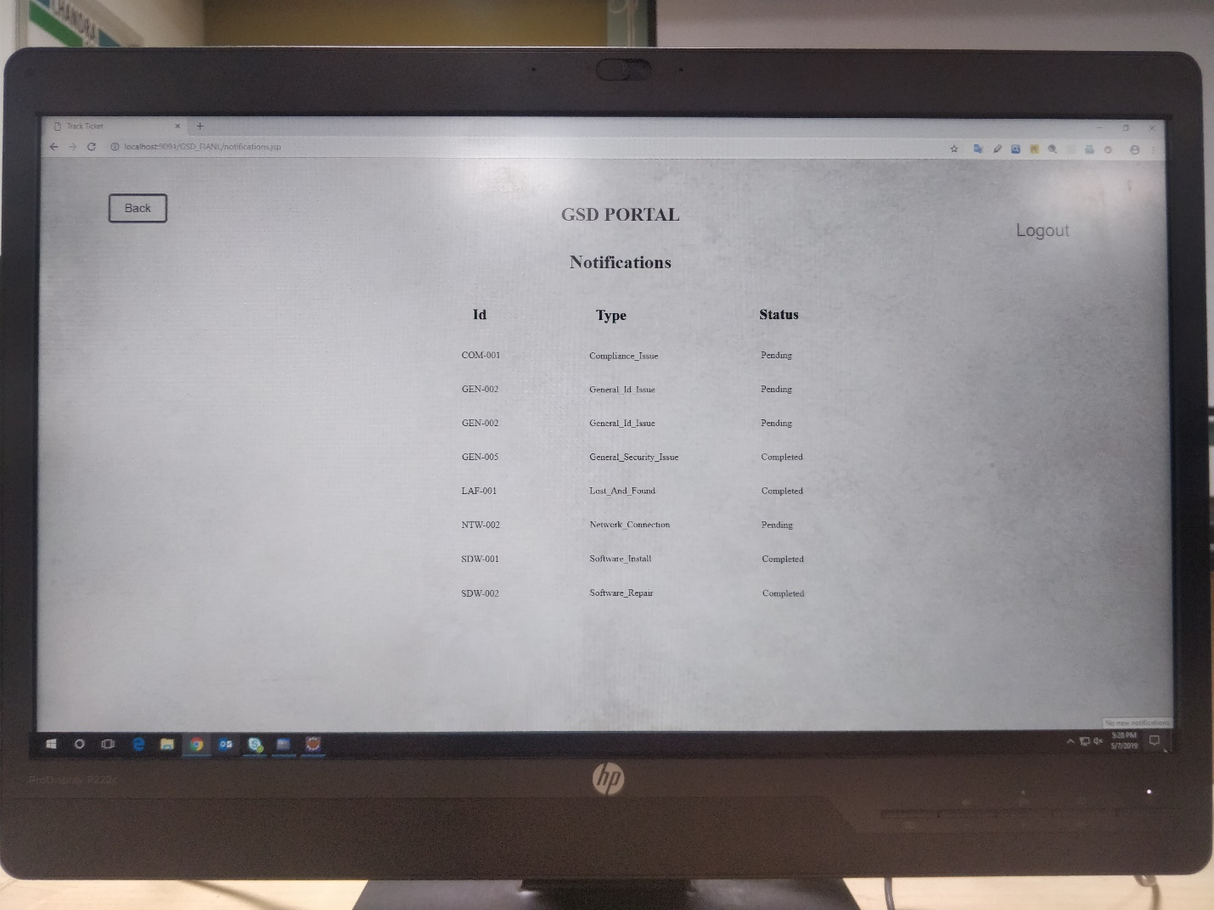

## Use case ‘User Close GSD.’

### Use case attributes.

**Scope:**

* User close gsd page.

**Actors:**

User – the operator

**Pre-Condition:**

User being able to close the request raised by them.

**Post Condition:**

User is in the Close request page.

**Flow of Events:**

User at Search GSD page 🡪 Click on close ticket 🡪 user at Close ticket page where list of gsd raised by user is present🡪 User selects the ticket to be closed and submits.

**Primary Scenario:**

A registered user – is able to get into the User close request page.

### Business Rules

Business rules should be defined using the following attributes:-

* Clicking on close request button for close request option.
* Getting all GSD of the user.
* Clicking ‘Close’ should check whether ticket is closed by admin or not.

### UI Requirements

Here is a prototype on how the user close request should look like.

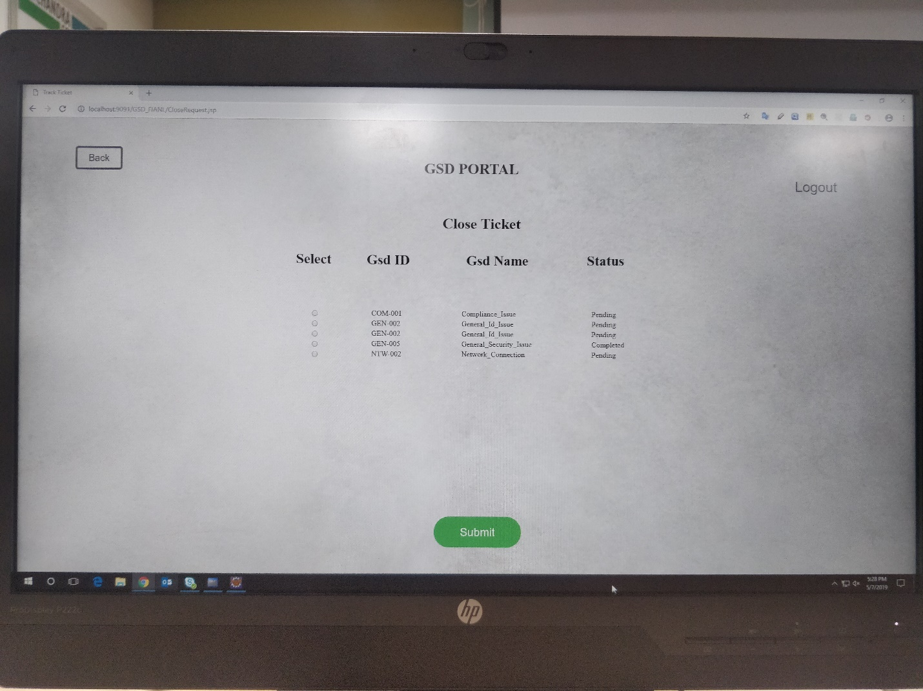

## Use case ‘Admin All GSD List’

### Use case attributes.

**Scope:**

* Admin All GSD list (admin homepage).

**Actors:**

Admin – the operator

**Pre-Condition:**

Admin being able to access the homepage

**Post Condition:**

User is in the All GSD List page.

**Flow of Events:**

Admin at All GSD page 🡪 List of gsds raised by the User.

**Primary Scenario:**

A registered admin – is able to get into the homepage i.e. All GSD, where he can view all the gsd tickets raised by the user.

### Business Rules

Business rules should be defined using the following attributes:-

* Clicking ‘All List’ button to redirect to All Gsd page.
* Admin is able to access the user GSD list post the successful validation of the admin credentials.

### UI Requirements

Here is a prototype on how the Admin all GSD should look like.

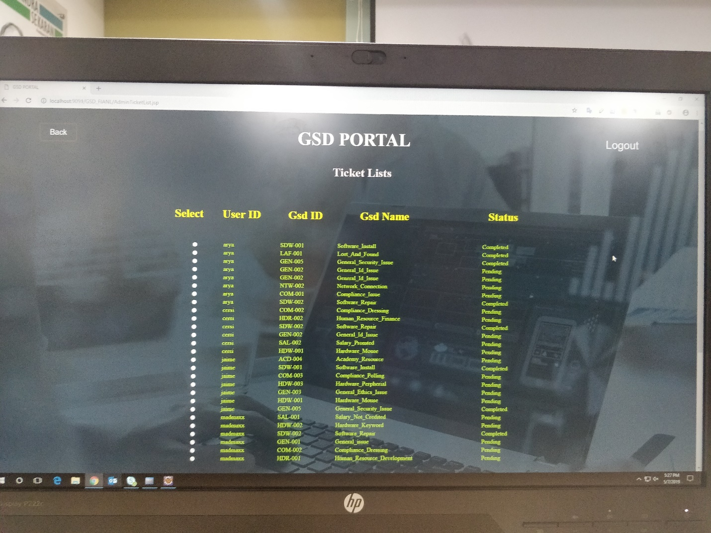

## Use case ‘Admin Close Request’

### Use case attributes.

**Scope:**

* Admin GSD list.

**Actors:**

Admin – the operator

**Pre-Condition:**

Admin being able to delete the gsd raised by user.

**Post Condition:**

User is in the Close GSD List page.

**Flow of Events:**

Admin at Close GSD page 🡪 List of gsds raised by the User 🡪 Admin chooses the gsd to be closed.

**Primary Scenario:**

A registered admin – is able to get into the homepage i.e. All GSD, then to the GSD list of the user he chooses and accordingly close the gsd ticket which gets deleted in the database and reflects the same on the user side.

### Business Rules

Business rules should be defined using the following attributes:-

* Clicking ‘All List’ button to redirect to All Gsd page.
* Admin is able to access the user GSD list post the successful validation of the admin credentials.

### UI Requirements

Here is a prototype on how the user login should look like.



**PURPOSE PROJECT PLANNING:**

The whole project is broken into 2 sprints of two weeks each. Under each sprint, the work of each day was finalized.

Global Service Desk has two main modules, User end, and Admin end. In the GSD management system, User raises ticket if he/she has any issues and the admin will view and close the ticket. We are using the agile methodology for planning and executing our project efficiently in the give time.

The modules are Admin Login, Admin registration, user login, user registration, search GSD page, raise ticket, close ticket, logout, All GSD list, track request. The person needs to login as user or admin whosoever he is. If the person has logged in as user, he will be redirected to the GSD page where he can either raise a ticket, check the notifications for the previously raised tickets or can close the ticket. If one has logged in as the admin, he has the access to all the tickets raised till date. He can view them and close them.

Using the agile methodology, our project is divided into scrums where the sprint length is two weeks. As soon as any of the module is completed either in the frontend or in the backend it is been simultaneously tested for bugs and fixed at the same time.

**REQUIREMENT TRACEABILITY**

|  |  |  |  |  |  |  |  |  |  |  |
| --- | --- | --- | --- | --- | --- | --- | --- | --- | --- | --- |
| **Story** | **Epic** | **NFR Requirements ID** | **Related Requirement ID** | **Interface Name** | **Language** | **Screen/ Wireframe ID** | **Component/ Class Diagram ID** | **Sequence Diagram** | **Use Interface Specification- Screen ID / Name** | **Database Tables** |
| UC 1.3 | NA | FS1 | FEA_1.1 | User Registration | Java | User registration Homepage | NA | Yes | User registration Homepage | user |
| UC 1.3 | NA | FS1 | FEA_1.2 | User login | Java | User login homepage | NA | Yes | User login homepage | user |
| UC 1.4 | NA | FS1 | FEA_1.3 | User Authentication | Java | authentication | NA | Yes | authentication | user |
| UC 1.3 | NA | FS2 | FEA_2.1 | User GSD Search | Java | gsd search homepage | NA | Yes | gsd search homepage | gsd |
| UC 1.4 | NA | FS2 | FEA_2.2 | User GSD raise | Java | gsd raise homepage | NA | Yes | gsd raise homepage | gsd |
| UC 1.5 | NA | FS3 | FEA_3.1 | User notification | Java | notification homepage | NA | Yes | notification homepage | NA |
| UC 1.5 | NA | FS3 | FEA_3.2 | User track request | Java | track request homepage | NA | Yes | track request homepage | gsd |
| UC 1.6 | NA | FS3 | FEA_3.3 | User close GSD | Java | close request homepage | NA | Yes | close request homepage | gsd |
| UC 1.6 | NA | FS4 | FEA_4.1 | User logout | Java | logout button | NA | Yes | logout button | NA |
| UC 1.7 | NA | FS5 | FEA_5.1 | Admin login | Java | admin login homepage | NA | Yes | admin login homepage | admin |
| UC 1.8 | NA | FS5 | FEA_5.2 | Admin registration | Java | admin registration homepage | NA | Yes | admin registration homepage | admin |
| UC 1.9 | NA | FS6 | FEA_6.1 | Admin all GSD list | Java | gsd list | NA | Yes | gsd list | gsd_details1 |
| UC 1.10 | NA | FS6 | FEA_6.2 | Adminclose request | Java | close request homepage | NA | Yes | close request homepage | gsd |
| UC 1.11 | NA | FS7 | FEA_7.1 | Admin logout | Java | admin logout button | NA | Yes | admin logout button | NA |
| UC 1.3 | NA | FS1 | FEA_1.1 | User Registration | Java | User registration Homepage | NA | Yes | User registration Homepage | user |
| UC 1.3 | NA | FS1 | FEA_1.2 | User login | Java | User login homepage | NA | Yes | User login homepage | user |
| UC 1.4 | NA | FS1 | FEA_1.3 | User Authentication | Java | authentication | NA | Yes | authentication | user |
| UC 1.3 | NA | FS2 | FEA_2.1 | User GSD Search | Java | gsd search homepage | NA | Yes | gsd search homepage | gsd |
| UC 1.4 | NA | FS2 | FEA_2.2 | User GSD raise | Java | gsd raise homepage | NA | Yes | gsd raise homepage | gsd |

**TEST LOG:**

|  |  |  |  |  |  |  |  |
| --- | --- | --- | --- | --- | --- | --- | --- |
|  |  |  |  |  |  |  |  |
| Test Design |  | Step 01 | Access the homepage | NA | User should be able to view the homepage | User able to view homepage | PASS |
| Test Design |  | Step 01 | Verify credentials | NA | User should be able to view the homepage | User able to view homepage | PASS |
|  |  | Step 02 | View the user GSD search homepage | NA | User should be able to view the User GSD homepage | User able to view the User Registration page | PASS |
|  |  | Step 03 | Key in user details | NA | User should be able key in user details | User details are displayed under each field | PASS |
|  |  | Step 04 | Field Validation upon Submit | NA | Field level datatype validations are performed upon Submit | Field level datatype validations are performed upon Submit | PASS |
| Test Design |  | Step 01 | Access the homepage | NA | User should be able to view the homepage | User able to view homepage | PASS |
|  |  | Step 02 | View the user GSD search homepage. | NA | User should be able to view the User Registration page | User able to view the User Registration page | PASS |
|  |  | Step 03 | Key in search bar | NA | Key in string pattern in search field & Click on search icon | System redirects to raise ticket page and if error then doesn't redirect. | PASS |
| Test Design |  | Step 01 | Access the raise ticket page | NA | User should be able to view the raise ticket page with the list of gsds having radio button | User able to view all gsds on the raise ticket page | PASS |
| Test Design |  | Step 01 | Verify credentials and validity of values | NA | Mandatory information is to be verified | User able to redirect to raise ticket page based on the information given. | PASS |
|  |  | Step 02 | Verify credentials | NA | Mandatory information is to be verified | If fields are missed out it is highlighted in red | PASS |
| Test Design |  | Step 01 | Access the gsd raise ticket page | NA | User should be able to view the raise ticket page | User able to view raise ticket page | PASS |
|  |  | Step 02 | Display of lists of gsds | NA | User should be able to select the ticket to be raised choosing the radio button and submit | if ticket is raised successfully id is generated and stored in database | PASS |
| Test Design |  | Step 01 | Access the notifications page | NA | User should be able to view the notifications page | User able to view notifications page | PASS |
|  |  | Step 02 | User must have raised request till current date. If no request found in db then empty list in notifications | NA | User should be able to key in view all the tickets raised and if no tickets in db shows an empty list | System displays all the user notifications | PASS |
| Test Design |  | Step 01 | Access the track request page | NA | User should be able to view the track request page | User able to view track request page | PASS |
|  |  | Step 02 | View the user track request page | NA | User should be able to view the track request page | User able to view the track request page | PASS |
|  |  | Step 03 | Clicking on track request button for redirecting to track request page | NA | User should be able to redirect track request page | User is able to redirect track request page | PASS |
| Test Design |  | Step 01 | Getting all gsds of user | NA | User should be able to view all the gsds raised | User able to view close gsd page | PASS |
|  |  | Step 02 | clicking close should check whether ticket is closed by admin or not | NA | User should be able to close the ticket based on the notification received by admin | User able to view close ticket | PASS |

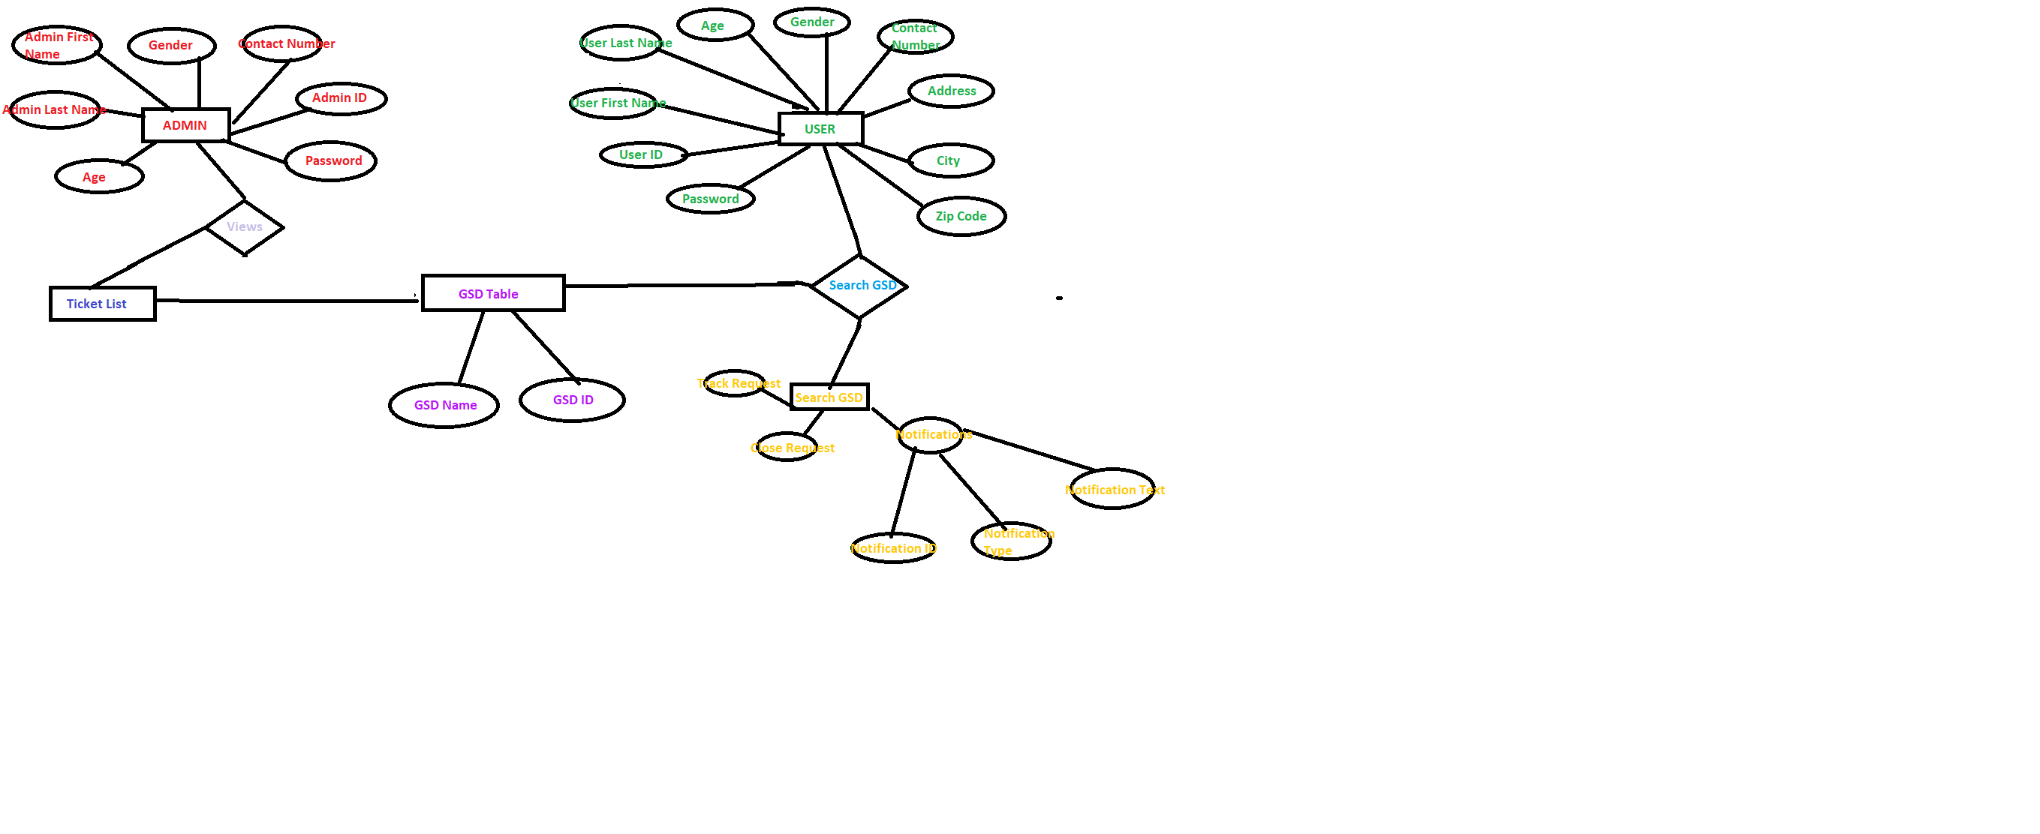

**References:**

[1] Collier, Ken W. (2011). Agile Analytics: A Value-Driven Approach to Business Intelligence and Data Warehousing. Pearson Education. pp. 121 ff. ISBN 9780321669544. What is a self-organizing team?

[2] Rally (2010). "Agile with a Capital "A" Vs. agile With a Lowercase "a". Archived from the original on 5 January 2016. Retrieved 9 September 2015.

[3] "Waterfall Software Development Model". 5 February 2014*.* Retrieved 11 August 2014.

[4] Jim Highsmith (2001). "History: The Agile Manifesto". agilemanifesto.org.

[5]https://www.dummies.com/careers/project-management/agile-project-management-for-dummies-cheat-sheet/

[*]https://www.peerbits.com/blog/agile-software-development.html